AUDIO RETREAT
Easter People audio retreat 2023 | Week Four | By the shores of the sea [John 21.1-19]

Prayer and reflection resource
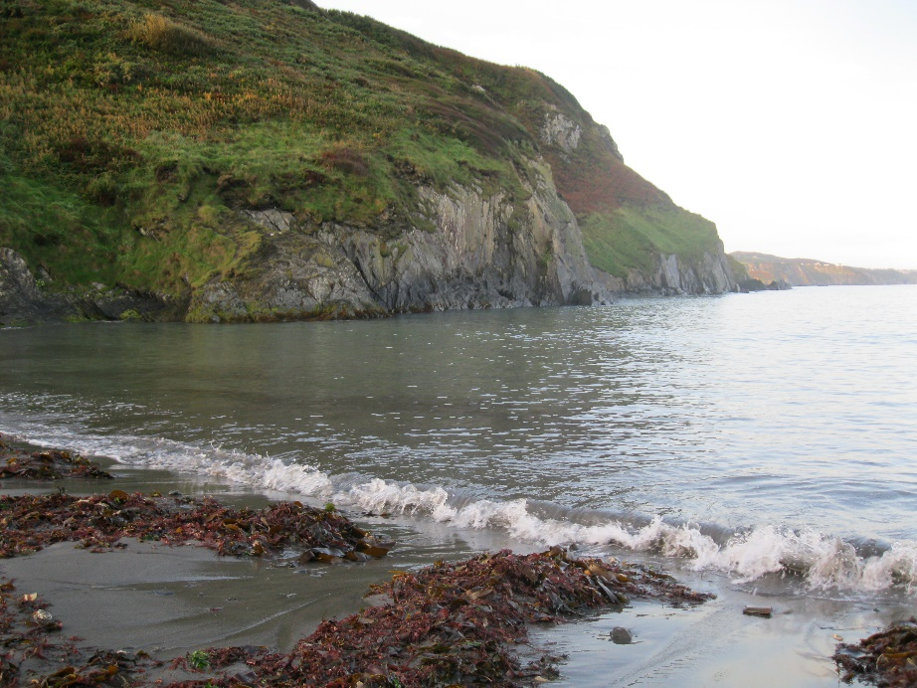

When they had gone ashore, they saw a charcoal fire there, with fish on it, and bread…Jesus said to them, ‘Come and have breakfast’.
[John 21.1-19]

“Enter the scene”
Before you begin this visual exercise, read John 21.1-19.
Once you’ve read the words, enter into the scene using your imagination and all your senses.
Listen to the waves as they move against the boat; see the light fading as night deepens; watch as the nets go into the sea.
Stay with the experience of being in the boat and what it feels like to be there.
Go with the story as it continues to unfold. Notice what moves you: the dawning light, the recognition of Jesus on the shore, the fire lit, the invitation to breakfast, the experience of sitting together…
In John 21.15-19, the story continues with Jesus’ dialogue with Simon Peter.
Allow this scene to prompt your own conversation with Jesus. The words, the questions, and the responses may be different for you.
Share what is on your mind or in your heart. Listen to what he seems to say to you.

“Heaven in ordinary”
The line “Heaven in ordinary” a line from George Herbert’s poem ‘Prayer’.
In the poem, rather than trying to define the concept of prayer, George Herbert layers image on image to express the experience and effect of the encounter.
The language – dating from the time of Shakespeare – is not always familiar. Nevertheless, these word pictures may communicate something that resonates with you.
Prayer, the Church’s Banquet, Angel’s age,
God’s breath in man returning to his birth
The soul in paraphrase, heart in pilgrimage,
The Christian plummet, sounding heaven and earth;
Engine against the almighty, sinner’s tower,
Reversed thunder, Christ-side-piercing spear,
The six days’ world transposing in an hour,
A kind of tune that all things hear and fear;
Softness, and peace, and joy, and love, and bliss,
Exalted manna, gladness of the best,
Heaven in ordinary, man well drest,
The milky way, the bird of Paradise,
Church-bells beyond the stars heard, the soul’s blood,
The land of spices; something understood.

Familiar tasks
Read this excerpt from the audio retreat: “Sometimes, when I want my mind to have fresh ideas and it isn’t playing, or my mind is too full of thoughts and I want to find rest, a physical activity like sanding a bench is what works for me. It asks enough attention to help me move out from a cluttered head space to a restful plain where, unbidden, new insights can move in or tired thoughts can find rest.”
What everyday (or occasional) activity has the capacity to gently hold your attention and still you? Perhaps the familiarity of this task might help you to be more present to your deeper self and to God?
This isn’t about trying to make something happen; it is about being open to ‘what is’.

Four Gospels / Icons of Easter
Over the next few days, revisit these four Easter narratives listed here. Notice what thoughts, feelings, or connections you are led to make.
- Mary Magdalene at the garden tomb [John 20.1-18]
- Two disciples on the Emmaus Road [Luke 24.13-35]
- Jesus enters the room where the disciples are gathered [John 20.19-23]
- Breakfast by the seashore [John 21.1-19]

